Project 2
<Hangman>

CSC – 5
Name: David W. Smith
Date: 02/12/14

Introduction:

Hangman is a game well-known to most young children, and (at least in principle) TV viewers, since this is the premise of the game show “Wheel of Fortune”. The objective is simple – a random word is selected, and the player guesses letters. A correct guess gets all instances of that letter displayed in the proper sequence in the word, and an incorrect guess causes a part of the 'hangman' to be displayed. If the player guesses all letters in the word successfully, the game is won, and if the hangman is completed before all the letters are guessed, the game is lost. Completing the hangman typically consists of 9 incorrect guesses (head, neck, both arms, torso, both legs, both feet) and is so implemented in this version.

Summary:
Project coded in C++ using NetBeans IDE & Cygwin Linux emulator.
Total lines of code – approx. 199, with limited comments.
Basic game play has been confirmed – heavily modularized, but missing sample code constructs such as sortation, pointers, file I/O among others.

Description:
An opening screen is displayed, showing the Gallows, a cheery welcome message, and a 'Letter?' prompt. The program will accept any character (valid ones are automatically converted to uppercase) but any invalid input (numbers, special characters, etc.) will be counted as a bad guess. 9 bad guesses ends the game, as does correctly guessing all the letters in the word or any combination of both.

Pseudocode:

Program execution begins here - Function main(var argc, var **argv)
Define local constants
Define local variables
Seed random number generator
Initialize word list & display matrix
Main execution loop
do
Call function doHang() - play 1 game of Hangman
Confirm with user - are we done?
Convert response to uppercase via upCase() function
while user response = 'Y'
Program execution ends here - Exit, stage right
End of function main()

Function upCase(var chkIt)
If value in chkIt is a lowercase alphabetic character
Convert to uppercase alphabetic character
End of function upCase()

Function iniWord(var words[][])
Load words into variable words, creating a list of words to select from
End of function iniWords()

Function iniDisp(var dMatrix[][])
Load dMatrix variable (display matrix) with characters making up gallows, stage &
list of asterisks (***...) where word should appear.
End of function iniDisp()

Function doHang(var dMatrix[][], var words[][], var rows, var cols, var totWrds) {
Define local variables
Randomly pick a word, get its length & location in array
Initialize display matrix, print cheery welcome message & display empty gallows
Start of main execution loop
Do
Ask user for a letter (convert to uppercase)
If user entered a letter
Use function strFind() to locate all instances of the letter in the word
If letter was found in word
Call function dspHang() to display updated word/gallows display
Display “Found letter.”
Else if letter not found
Increment badLetr variable
Call updtHng() to update the Hangman
Call dspHang() to display updated word/gallows display
Display “Letter not found.”
Endif
Else if user did not enter a letter
Increment badLetr variable
Call updtHng() to update the Hangman
Call dspHang() to display updated word/gallows display
Display “Letter not found.”
Endif
Call strncmp() function to see if word in display matches selected word (e.g. are they equal)
While the word is not complete and the Hangman is not complete
End of main execution loop
Check to see whether the user has won or lost
If the word is complete
Display “YOU WON!”
Else if the Hangman is complete
Display “YOU LOST!”
Endif
End of function doHang()

Function dspHang(var dMatrix[][], var rows)
For row = 0 while row <= rows-1
For col = 0 while col <= DISP_COL-1
If dMatrix[row][col] does not contain a null terminator character '\0'
Display dMatrix[row][col];
Else
Display EOL & force end of column display
Endif
End for col...
End for row...
End of function dspHang()

Function updtHng(var dMatrix[][], var errCnt)
This function puts a part of the Hangman into the display matrix at the proper location, based on the number of errors the user has had.
Case errCnt = 1
dMatrix[3][9] = 'O'
Case errCnt = 2
dMatrix[4][9] = '|'
Case errCnt = 3
dMatrix[4][8] = '\'
Case errCnt = 4
dMatrix[4][10] = '/'
Case errCnt = 5
dMatrix[5][9] = '|'
Case errCnt = 6
dMatrix[6][8] = '/'
Case errCnt = 7
dMatrix[6][10] = '\'
Case errCnt = 8
dMatrix[7][7] = '-'
Case errCnt = 9
dMatrix[7][11] = '-'
End of function updtHng()

Function strFind(var wrd[], var ltr, var len, var display[][])
Set isFnd flag to FALSE
For i = 0 while i < len && wrd[i] is not equal to null terminator '\0'
If wrd[i] = ltr
set isFnd flag to TRUE
display[11][i] = ltr
Endif
End for i...
return isFnd flag to calling function
End of function strFind()

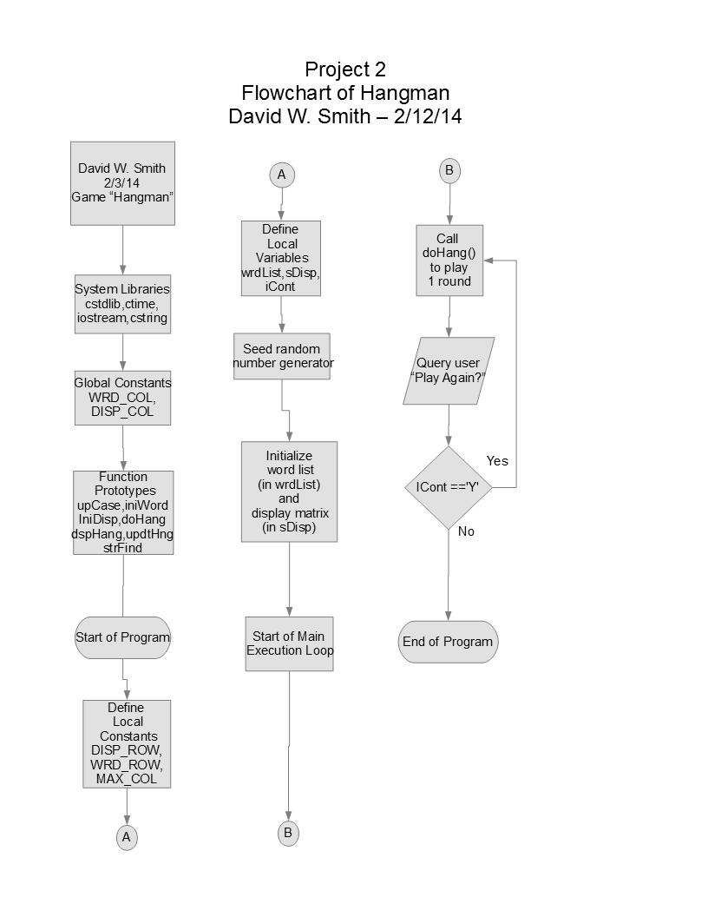
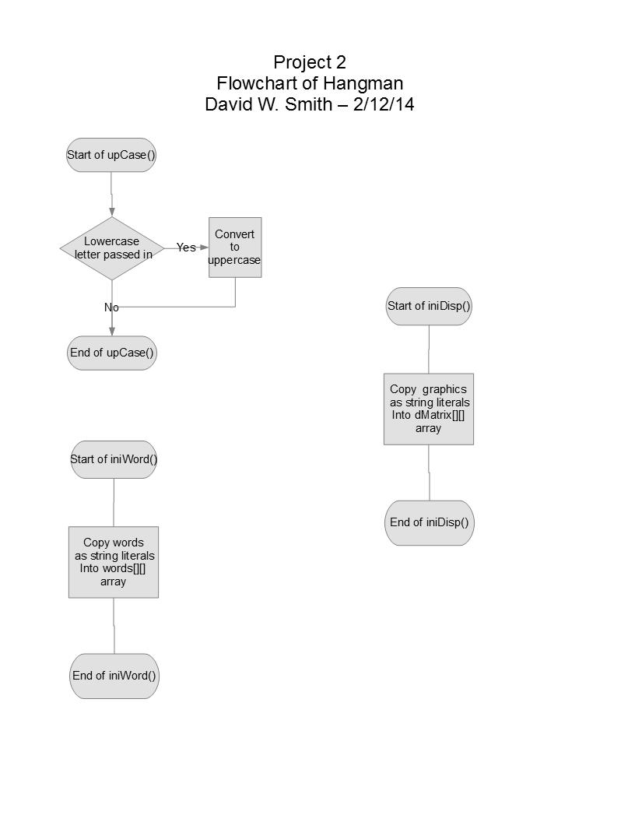
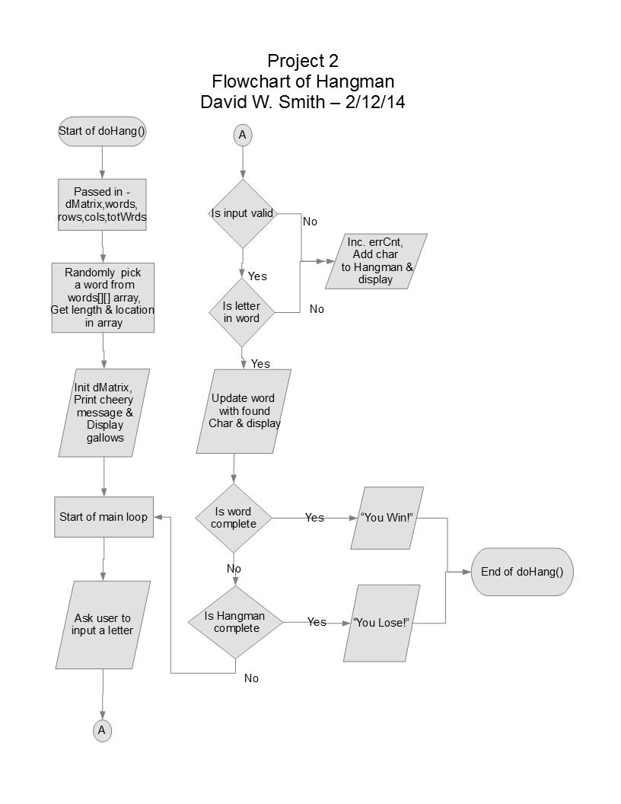
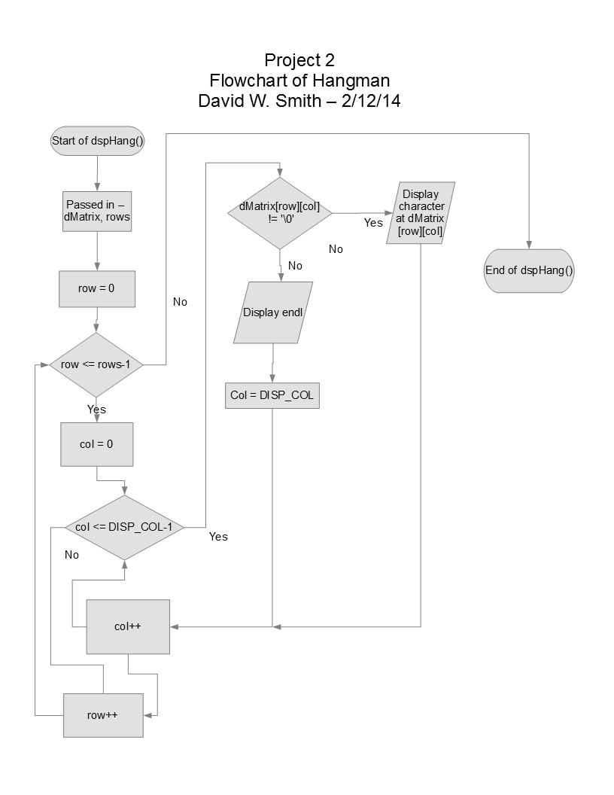
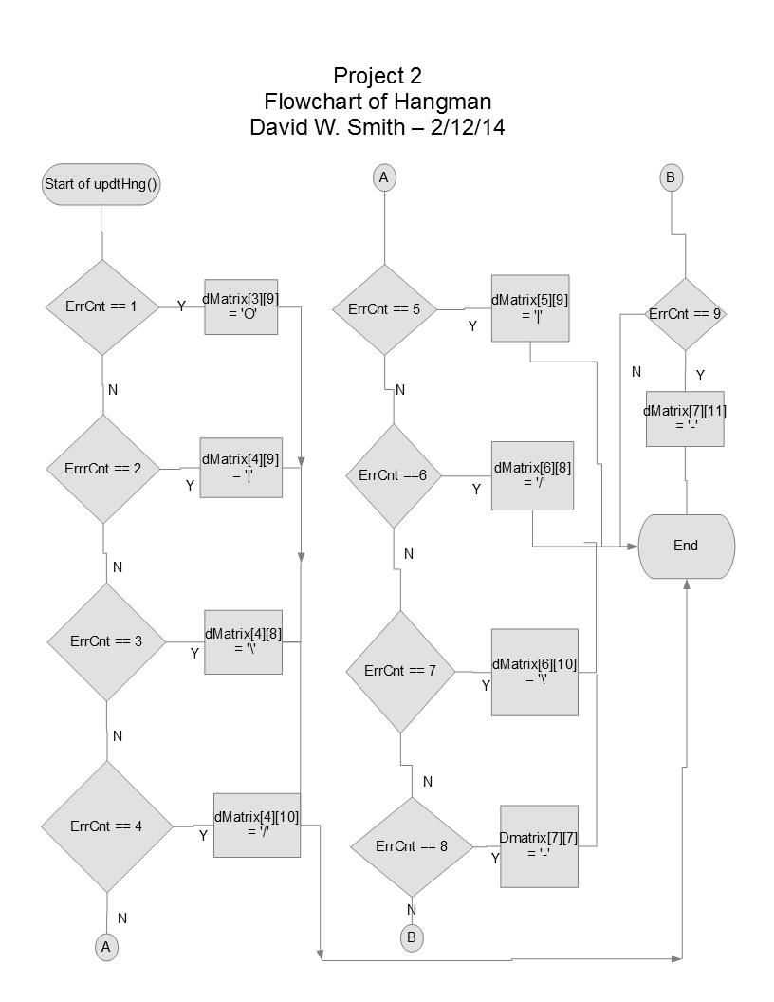
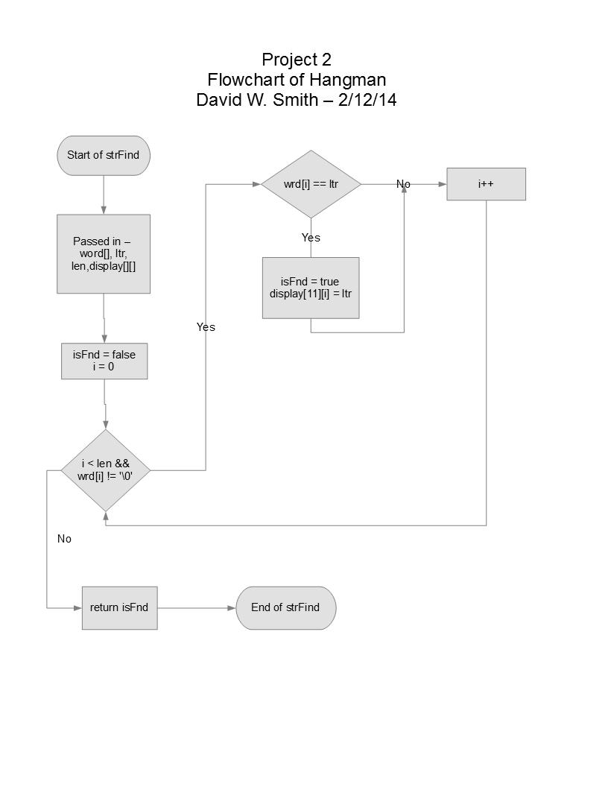
Table 1 – List of Variables & Constants used in HANGMAN
Name | Type | Where defined
WRD_COL, DISP_COL | Const int | Global constant
DISP_ROW, WRD_ROW, MAX_WORD | Const int | Local constants in main()
wrdList[][], sDisp[][], iCont | Char | Local variables in main()
chkIt | Char | Parameter used in upCase()
words[][] | Char | Parameter used in iniWord(), doHang()
dMatrix[][] | Char | Parameter used in iniDisp(), doHang(),dspHang(), updtHng()
rows, cols, totWrds | Int | Parameters used in doHang(), dspHang()
word[], letr | Char | Local variables used in doHang()
badLetr,wrdLen,wrdLoc | Unsigned short | Local variables used in doHang()
isWord | Bool | Local variable used in doHang()
row, col | Int | Local variables used in dspHang()
errCnt | Unsigned short | Parameter used in updtHng()
wrd[], ltr, display[][] | Char | Parameters used in strFind()
len | Unsigned short | Parameter used in strFind()
isFnd | bool | Local variable used in strFind()

Table 2 – Program constructs used in HANGMAN
Type | Where used
Functions | From main() on down – C++ uses them heavily.
Overloaded functions | iniWord()
If-Then | strFind()
Nested If-Then | doHang()
Ternary Operators | upCase()
Switch | updtHng()
While loops | doHang()
Do-while loops | main()
For loops | strFind()
Nested loops | dspHang()
Strings | iniWord()
Vectors | wrdSort()
Sortation | wrdSort()
Pass by Value | main(), doHang()
Pass by Reference | upCase(), main()
Defaulted Parameters | doHang()
Returning primitive data types | strFind()
Output formatting | dspHang()
Read from file | iniWord()
Write to file | wrdSort()

References:
“Pearson Custom Computer Science” - Excerpts from “Problem Solving in C++”, 8th Ed. - Walter Savitch
“Basic Computer Games” – David H. Ahl
“The C Programming Language” - Kernighan & Ritchie
https://github.com/IEDave/ds2490286/Hangman

